# ABSTRACT

This Project approaches the design and development of a System that combines the technologies with the implementation of a City Portal System. The main idea behind the development of this system was to build a System that would focus entirely on a particular city and would provide the ultimate guide of that city. Many existing systems are there but they are not so user friendly and doesn’t focus on all modules of the entire city.

As Cities are turning into Smart Cities there was a need to make a system that can be used to not only focus on a particular City but can even Change Cities as per requirement and can provide the guide about a city. The city portal will provide various type and variety of information like City News, Places of Tourist Interest, Festivals, History, Cinemas, Daily Happenings, Business Directory, Online Local Store, Local Transportation Details, Real Estate and many more.

I have added all important modules in our System So that even a Naive Person can get the guide that he or she intends to get from the System easily. Our system would be having an Online Local Store from which a user can buys goods from nearby Local Store. Idea behind this was to promote the local store in online business and earn maximum profits to them.

The application also has Local Transportation System guide that provide all details related to local transport that exists in particular cities. Apart from this, there are various modules like the Events module, Business directory etc.

The application has Progressive web Application (PWA) for mobile device.

**INDEX**

|  |  |  |  |
| --- | --- | --- | --- |
|  |  |  |  |
|  | Abstract | | |
|  |
| Sr. No. | | | Content |
|  | | |  |
| **1** | **Chapter 1 : Introduction** | | |
|  | 1.1 |  | Introduction |
|  | 1.2 |  | Existing System |
|  | 1.3 |  | Need For New System |
|  | 1.4 |  | Work Plan |
| **2** | **Chapter 2 : Requirement Specification** | | |
|  | 2.1 |  | Functional Requirements |
|  | 2.2 |  | Non Functional Requirements |
|  | 2.3 |  | Hardware Requirements |
|  | 2.4 |  | Software Requirements |
|  | 2.5 |  | Feasibilty Study |
|  |  | 2.5.1 | Technical Feasibilty |
|  |  | 2.5.2 | Economic Feasibilty |
| **3** | **Chapter 3 : System Design** | | |
|  | 3.1 |  | System Architecture |
|  | 3.2 |  | System Diagrams |
|  |  | 3.2.1 | Class Diagram |
|  |  | 3.2.2 | Use Case Diagram |
|  |  | 3.2.3 | Activity Diagram |
|  |  | 3.2.4 | State Diagram |
|  |  | 3.2.5 | Sequence Diagram |
|  |  | 3.2.6 | Data Flow Diagram |
|  | 3.3 |  | Database Design |
|  |  | 3.3.1 | Data Dictionary |
| **4** | **Chapter 4 : System Description** | | |
|  | 4.1 |  | Software Description |
| **5** | **Chapter 5 : System Implementation** | | |
| **6** | **Chapter 6 : Conclusion** | | |
|  |  |  |  |
|  | Reference | | |
|  | Appendix A | | |
|  | Appendix B | | |

**List Of Figures:**

|  |  |
| --- | --- |
| Sr. No. | Title |
| Figure 1.1 | Work Plan |
| Figure 3.1 | System Architecture |
| Figure 3.2 | Class Diagram |
| Figure 3.3 | Use Case Diagram |
| Figure 3.4 | Activity Diagram |
| Figure 3.5 | Activity Diagram Admin |
| Figure 3.6 | Activity Diagram User |
| Figure 3.7 | State Diagram |
| Figure 3.8 | Sequence Diagram |
| Figure 3.9 | Sequence Diagram User |
| Figure 3.10 | Data Flow Diagram |
| Figure 3.11 | Data Flow Real Estate Module |
| Figure 3.12 | Data Flow Business Directory Module |
| Figure 3.13 | Data Flow For Various Module |
| Figure 3.14 | Data Flow For Online Store Module |
| Figure 5.1 | Website Home Page |
| Figure 5.2 | Website Home Page |
| Figure 5.3 | Website Home Page |
| Figure 5.4 | Website News Module |
| Figure 5.5 | Website Online Store Module |
| Figure 5.6 | Website Store Cart Page |
| Figure 5.7 | Website Directory Page |
| Figure 5.8 | Mobile Home Page |
| Figure 5.9 | Mobile News and Event Page |
| Figure 5.10 | Mobile Online Store Page |
| Figure 5.11 | Mobile City Guide Page |

|  |  |  |
| --- | --- | --- |
|  |  |  |
|  | | |
|  |  |  |
|  |  |  |

# INTRODUCTION

**1.1 INTRODUCTION:**

In Recent Years, there has been a great Increase in Development of Different Cities. For this Reason, Numerous Systems have been made on focusing of a Particular City and providing the Guide to that City.

This Project approaches the design and development of a System that Combines the Technologies with the implementation of a City Portal System. The main idea behind the Development of this System was to build a system that would focus entirely on a Particular City and would provide the Ultimate Guide of that City. Many Existing System are there but they are not so User Friendly and don’t focus on the all aspects of the Entire City.

As Cities are turning into Smart Cities there was a need to make a System that can be used to not only focus on a Particular City but can even Change Cities as per requirement and can become the Guide about a City. The City Portal will provide Various Type and Variety of Information like City News, Places of Tourist Interest, Festivals, History, Cinemas, Daily Happenings, Business Directory, Online Local Store, Local Transportation Details, Real Estate and many more.

City News Module will provide the daily happenings in the City and would provide the latest News about the City. Some of the exciting features of this would be that Updating of News would be done frequently So latest News would reach the audience, user can even get the meaning of some words from System itself rather than using Dictionary for it.

Business Directory Module will provide the user the ability to get in touch with various businesses in a Particular City and could even Contact them in case of any needs. The main aim behind this module was to distance the gap between user and various businesses So that the User can get what they want in no time and to make their life easier.

Online Local Store Module focuses on Local Store in a Particular City So that the User can buy Goods from their Trusted Local Store in their Cities Online by using the application rather than going their personally. Main aim behind this module was that in this Era of Competition; let the Local Store grow Continuously in the market and obtain maximum profits. Also, the Customers will be able to get Goods from their Nearby Local Store rather Than From Different Online Stores.

Events Module focuses on the Various Events in a Particular City. User can View the Information about an Event, can get to know the Overall Details about the Events and Can Even make Bookings for the Events from our Application itself.

Local Transportation Module focuses on the Local Transportation System. It would provide Schedule of the local transportation in that Particular City along with some existing features like the exact arrival time, departure time and the position of the various buses at particular instance of time.

The application has a Progressive Web Application (PWA) rather than an Android Application as it is Lightweight than android and would provide the same Experience to the User. So that the User Can get the exact same thing while saving his memory also.

* 1. **EXISTING SYSTEM:**

There are some Existing System which focuses on particular city and provides information related to that city but the information provided by them is not accurate and it provides very less information.

Also the existing System has very less functionality and the user interface of the application is not so user friendly that can be engaging to the User.

* 1. **NEED FOR NEW SYSTEM:**

The new System explores the city in better way and provides the ultimate guide about the city.Also we have added many new modules in our system that would be more useful to the users and would help them in better way.

Some of the new modules that we have added to our system are as follows:

Online Local Store Module focuses on Local Store in a Particular City So that the User can buy Goods from their Trusted Local Store in their Cities Online by using the application rather than going their personally. Main aim behind this module was that in this Era of Competition; let the Local Store grow Continuously in the market and Obtain maximum profits. Also the Customers will be able to get Goods from their Nearby Local Store rather Than From Different Online Stores.

Local Transportation Module focuses on the Local Transportation System. It would provide Schedule of the local transportation in that Particular City along with some existing features like the exact arrival time, departure time and the position of the various buses at particular instance of time.

* 1. **WORK PLAN:**

|  |  |  |  |  |  |  |  |  |  |
| --- | --- | --- | --- | --- | --- | --- | --- | --- | --- |
|  |  |  |  |  |  |  |  |  |  |
| Event Module  News Module | Business Directory |  | Online Store  Movie Module |  | Real Estate | City Guide | Mobile Application |  |  |
| 5 Dec | 20 Dec | 4Jan | 19 Jan | 3 Feb | 18 Feb | 5 Mar | 20Mar | 4Apr | 9 Apr |

*Figure 1.1*

# REQUIREMENT SPECIFICATION

## FUNCTIONAL REQUIREMENTS:

* User should be able to login and register in the system easily.
* Easily navigate between different modules of system.
* Retrieve news of city.
* Retrieve Information of tourist places.
* Retrieve Information of different type of businesses in city.
* Search Products in online stores.
* It should place customers’ product order.
* It should manage different payment options.
* It should manage user account.
* Provide information like restaurants, movies, events and so on in city.
* Retrieve Information of different types of properties in city.
* It shows map of city.
* It shows time-table of city transport buses.
* It shows real time location of city transport bus location.
* User can add review about of interest.

## 2.2 NON-FUNCTIONAL REQUIREMENTS:

* User can use the system via Internet so Internet connection is must.
* The final system should scale correctly to support high traffic loads.
* The final system should be flexible.
* System should be User Friendly.
* Reliability
* Availability
* Maintainability
* Performance
* Reparability

## 2.3 HARDWARE REQUIREMENTS:

* It is a web-based project. So any personal computer, mobile phones, Tablet with a browser and internet connection with around 512MB RAM, Pentium-4 or above processor and Storage Space is enough for the system to work efficiently.
* On the Server Side we are basically having a Linux based Server with around 2GB RAM and Storage Capacity of around 2TB is required by the System to work efficiently.

## 2.4 SOFTWARE REQUIREMENTS:

* **Technologies:** Java, HTML5, CSS, Bootstrap, Angular JS
* **Framework:** Spring MVC
* **Database:** MySQL
* **Tools:** STS, Brackets, Sublime Text

## 2.5 FEASIBILITY STUDY:

**2.5.1 TECHNICAL FEASIBILITY:**

As Every Project, it is Crucial to Study its Feasibility in Order to Evaluate and Analyze its Potential. In fact, at the beginning of the semester, we had to Conduct an Extensive Investigation and Research to be a Support to the Process of Decision Making on the Different Aspects. This Section Will Summarize the Result of the Study.

First, the Technological Aspect is Considered as the main Criterion of Evaluation of the City Portal project. Therefore, it requires more attention choosing the right tools in order to fulfill the requirements.

We have designed application as being a Client-Server Architecture allowing the access from many endpoints such as mobiles, tablets, and laptops. This enforces the extendibility and accessibility features.

Also, there have been four levels that were mainly exploited. The first one which is the front-end development ended up deciding on using Bootstrap, an HTML and CSS to build the user Interface. Second, the back-end development is what Constitutes the Core business logic of the platform. We have decided to use Spring framework built with JAVA implementing the MVC paradigm. Data Storage is an important Component in the Application. In fact, there is a Clear need for persistent data; therefore, we had to Conduct a DBMS benchmarking to choose the right one. This brought us to decide of choosing MySQL. Finally, The REST with AngularJS is the paradigm chosen for the data communication.

Thus, our System is Feasible to all the requirements and would be made successfully.

**2.5.2 ECONOMIC FEASIBILITY:**

As our project is Web based Application, so the Production and Maintenance Cost Would be minimal.

In Online Local Store Modulewe would also be providing free marketing and selling of products online to the Sellers and So it would be economical feasible to the sellers.

# SYSTEM DESIGN

## SYSTEM ARCHITECTURE:

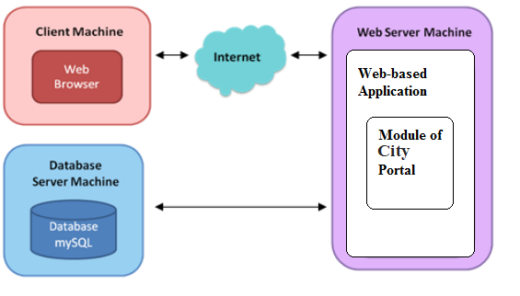

*Figure-3.1*

Our System Architecture Consists Of Client Machine, Database Server Machine and Web Server Machine. Client would be using Our Application through Internet using the Web Browser or as a Mobile Application. Data would be provided to the Client through Database Server Machine i.e. MySQL Database.

## SYSTEM DIAGRAM:

## 3.2.1 CLASS DIAGRAM:

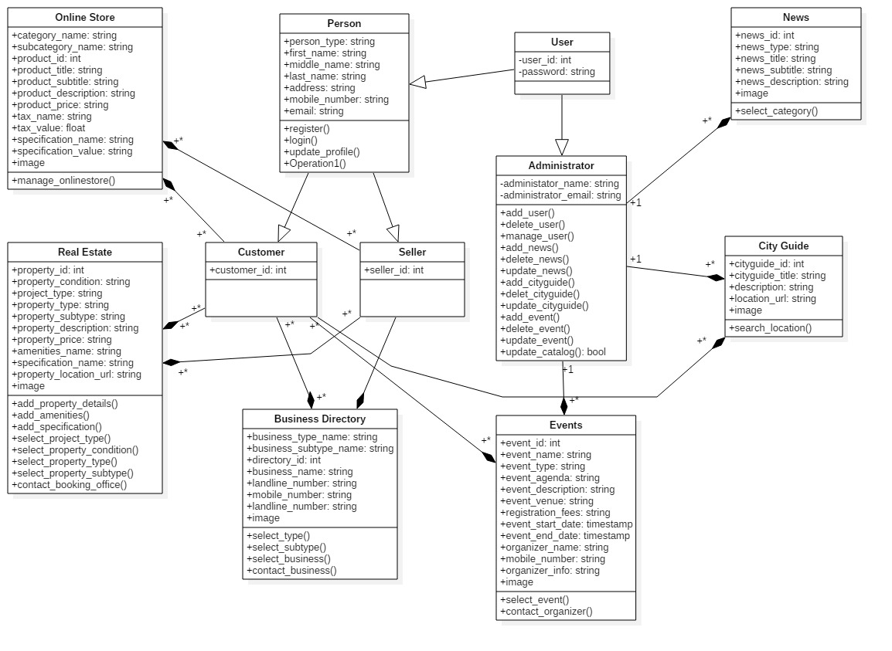

*Figure-3.2*

## 

## 3.2.2 USE- CASE DIAGRAM:

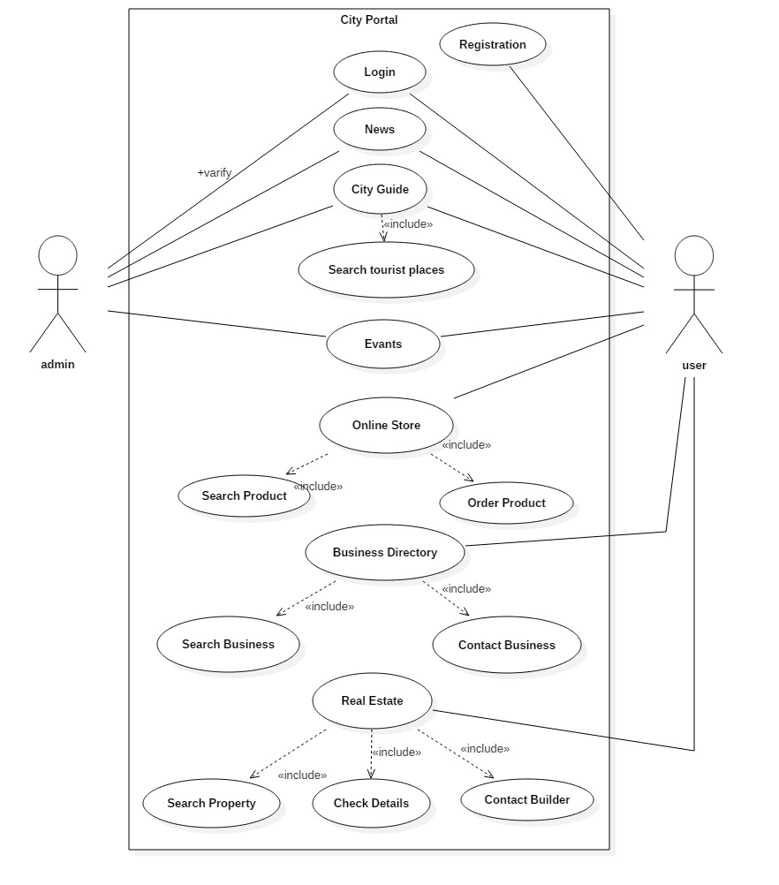

*Figure-3.3*

## 

## 3.2.3 ACTIVITY DIAGRAM:

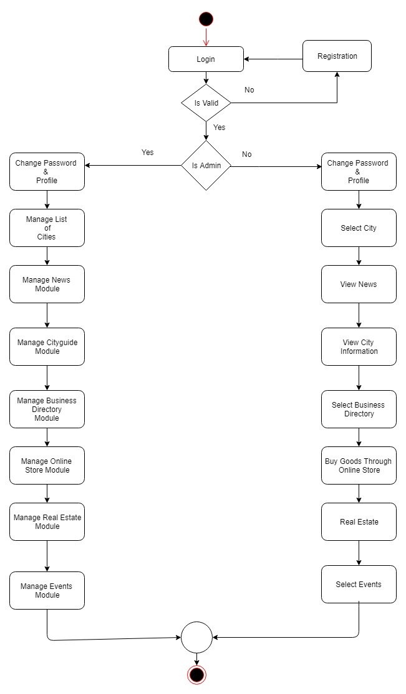

*Figure-3.4*

**ACTIVITY DIAGRAM ADMIN:**

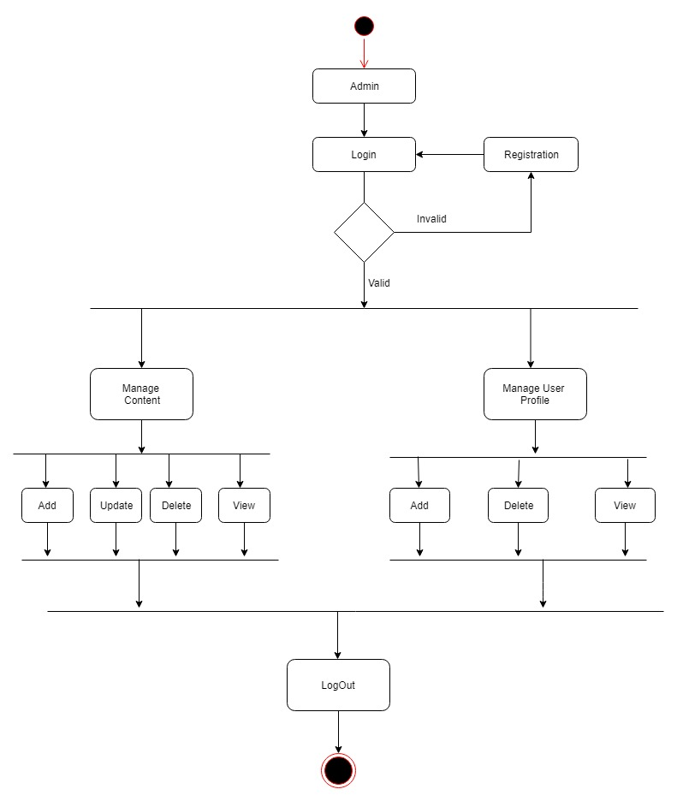

*Figure-3.5*

**ACTIVITY DIAGRAM USER:**

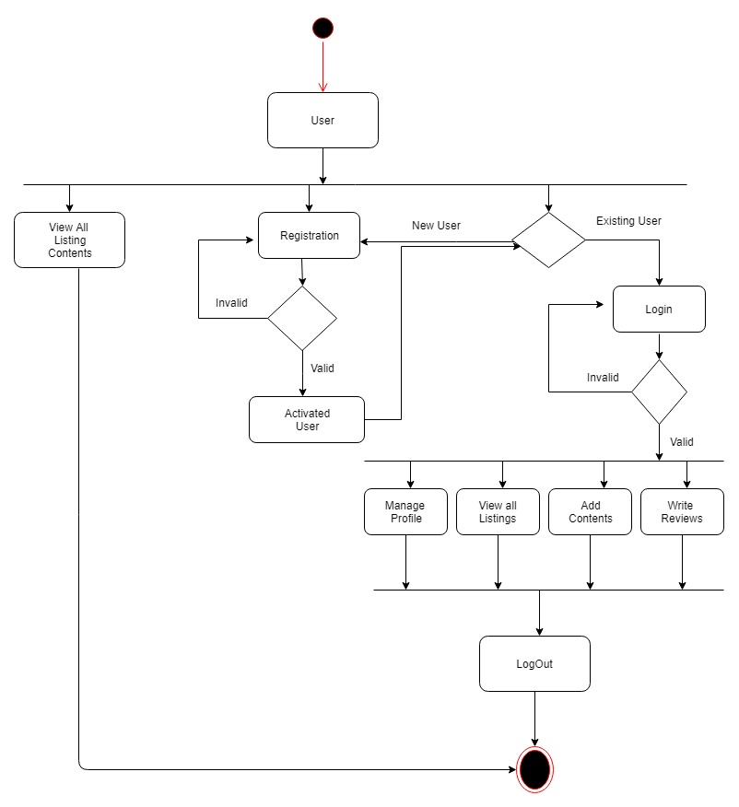

*Figure-3.6*

## 3.2.4 STATE DIAGRAM:

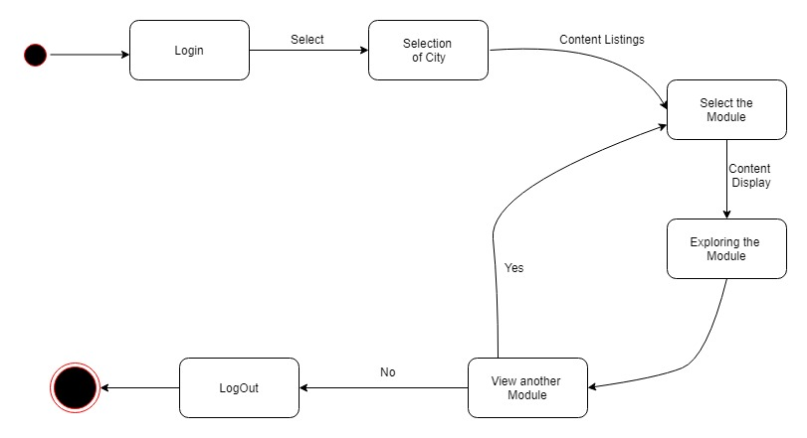

*Figure-3.7*

## 3.2.5 SEQUENCE DIAGRAM:

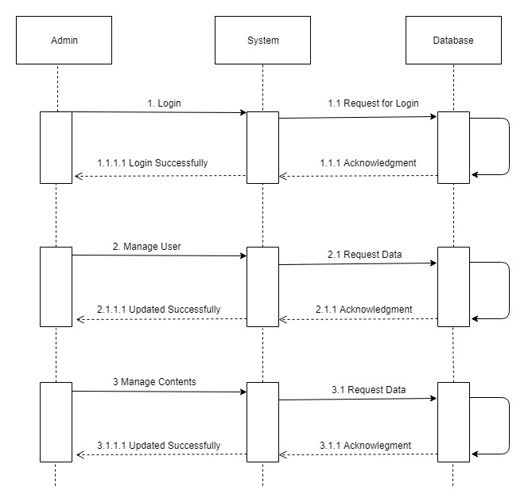

*Figure-3.8*

**SEQUENCE DIAGRAM FOR USER:**

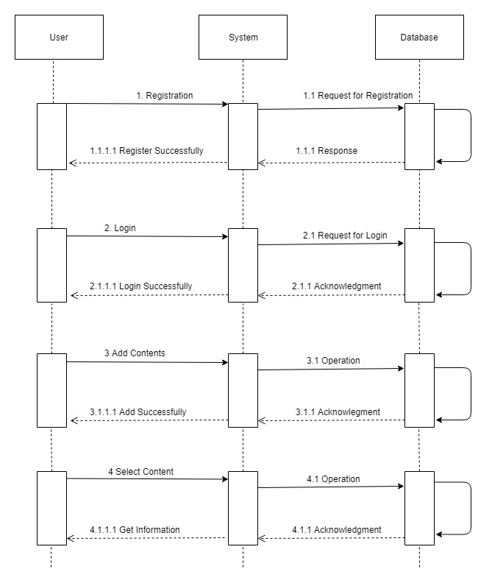

*Figure-3.9*

## 

## 3.2.6 DATA FLOW DIAGRAM:

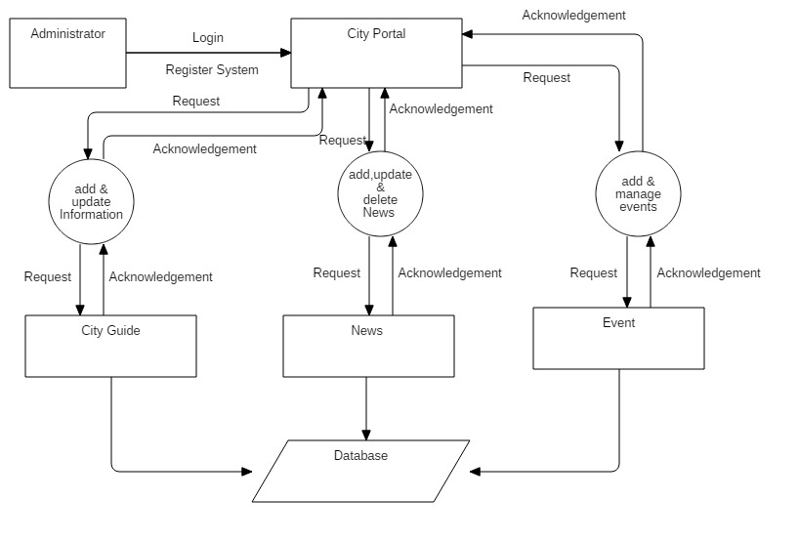

*Figure-3.10*

**DFD FOR REAL ESTATE MODULE:**

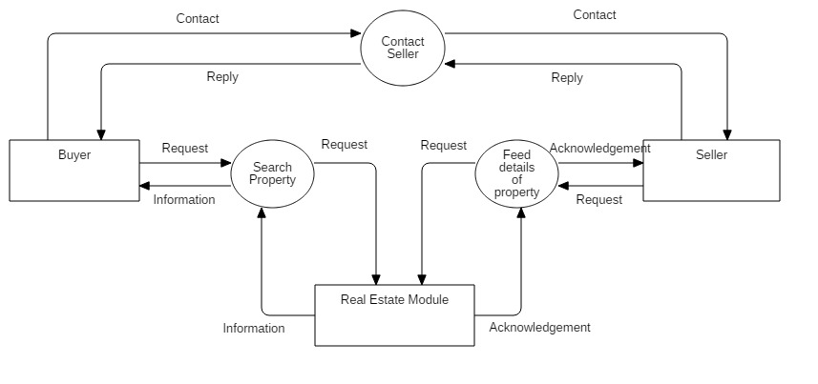

*Figure-3.11*

**DFD FOR BUSINESS DIRECTORY MODULE:**

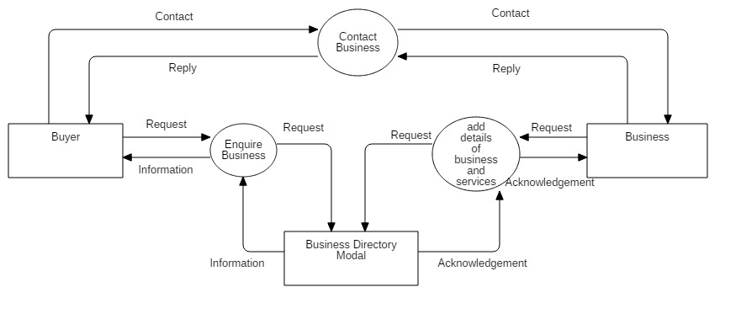

*Figure-3.12*

**DFD FOR VARIOUS MODULES:**

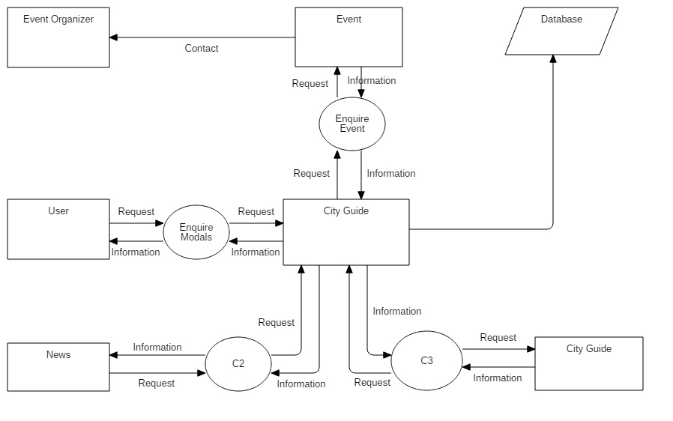

*Figure-3.13*

**DFD FOR ONLINE STORE MODULE:**

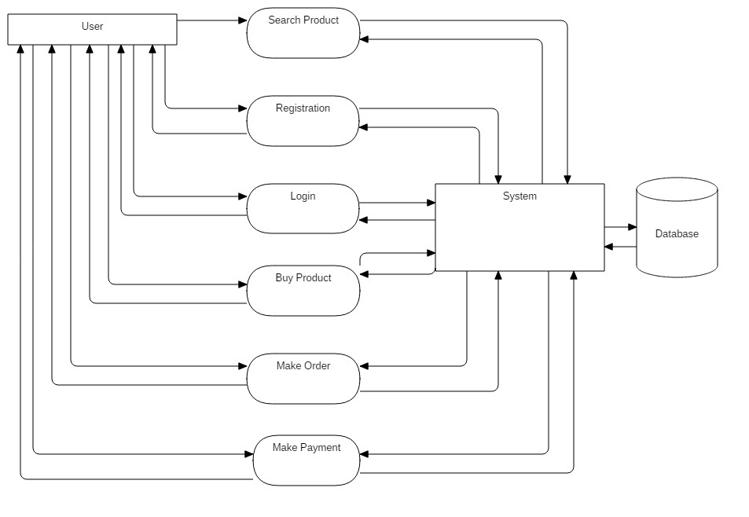

*Figure-3.14*

## DATABASE DESIGN:

**3.3.1 DATA DICTIONARY**

**1.country**

|  |  |  |  |
| --- | --- | --- | --- |
| **Name** | **Datatype** | **constraint** | **Comment** |
| country_id | Int | primary key |  |
| country_name | varchar(20) |  |  |
| country_code | varchar(10) |  | INR |
| country_dialing_code | varchar(4) |  | +91 |
| created_by | Int | foreign key |  |
| created_date | Timestamp |  |  |
| ip_address | varchar(15) |  |  |

**2.state**

|  |  |  |  |
| --- | --- | --- | --- |
| **Name** | **Datatype** | **constraint** | **Comment** |
| state_id | Int | primary key |  |
| state_name | varchar(20) |  |  |
| state_code | varchar(8) |  |  |
| country_id | Int | foreign key |  |
| created_by | Int | foreign key |  |
| created_date | Timestamp |  |  |
| ip_address | varchar(15) |  |  |

**3.city**

|  |  |  |  |
| --- | --- | --- | --- |
| **Name** | **Datatype** | **constraint** | **comment** |
| city_id | Int | primary key |  |
| city_name | varchar(20) |  |  |
| state_id | Int | foreign key |  |
| created_by | Int | foreign key |  |
| created_date | Timestamp |  |  |
| ip_address | varchar(15) |  |  |

**4.area**

|  |  |  |  |
| --- | --- | --- | --- |
| **Name** | **Datatype** | **constraint** | **comment** |
| area_id | Int | primary key |  |
| area_name | varchar(20) |  |  |
| area_code | varchar(10) |  | 390015 |
| city_id | Int | foreign key |  |
| created_by | Int | foreign key |  |
| created_date | Timestamp |  |  |
| ip_address | varchar(15) |  |  |

**5.images**

|  |  |  |  |
| --- | --- | --- | --- |
| **Name** | **Datatype** | **constraint** | **comment** |
| image_id | Int | primary key |  |
| image_url | Text |  |  |

**6.reviews**

|  |  |  |  |
| --- | --- | --- | --- |
| **Name** | **Datatype** | **constraint** | **comment** |
| review_id | Int | primary key |  |
| review_description | Text |  |  |

**7.news**

|  |  |  |  |
| --- | --- | --- | --- |
| **Name** | **Datatype** | **constraint** | **comment** |
| news_id | Int | primary key |  |
| news_title | varchar(100) |  | Title of the News |
| news_subtitle | varchar(100) |  |  |
| news_description | Text |  | Full Length News |
| image_id | Int | foreign key |  |
| news_type_id | Int | foreign key |  |
| created_by | Int | foreign key |  |
| created_date | Timestamp |  |  |
| ip_address | varchar(15) |  |  |

**8.news_type**

|  |  |  |  |
| --- | --- | --- | --- |
| **Name** | **Datatype** | **constraint** | **comment** |
| news_type_id | Int | primary key |  |
| news_type_name | varchar(50) |  | Categories(i.e Sports) |
| news_description | Text |  | Type Description |
| created_by | Int | foreign key |  |
| created_date | Timestamp |  |  |
| ip_address | varchar(15) |  |  |

**9.cityguide**

|  |  |  |  |
| --- | --- | --- | --- |
| **Name** | **Datatype** | **constraint** | **comment** |
| cityguide_id | Int | primary key |  |
| cityguide_title | varchar(30) |  | i.e Lifestyle |
| Description | Text |  |  |
| image_id | Int | foreign key |  |
| location_url | Text |  |  |
| created_by | Int | foreign key |  |
| created_date | Timestamp |  |  |
| ip_address | varchar(15) |  |  |

**10.business_directory_type**

|  |  |  |  |
| --- | --- | --- | --- |
| **Name** | **Datatype** | **constraint** | **comment** |
| business_type_id | Int | primary key |  |
| business_type_name | varchar(100) |  | Categories(i.e automobile) |
| created_by | Int | foreign key |  |
| created_date | Timestamp |  |  |
| ip_address | varchar(15) |  |  |

**11.business_directory_subtype**

|  |  |  |  |
| --- | --- | --- | --- |
| **Name** | **Datatype** | **constraint** | **comment** |
| business_subtype_id | Int | primary key |  |
| business_subtype_name | varchar(50) |  | Categories(i.e showroom) |
| business_type_id | Int | foreign key | (business directory type) |
| created_by | Int | foreign key |  |
| created_date | Timestamp |  |  |
| ip_address | varchar(15) |  |  |

**12.directory**

|  |  |  |  |
| --- | --- | --- | --- |
| **Name** | **Datatype** | **constraint** | **comment** |
| directory_id | Int | primary key |  |
| business_name | varchar(50) |  | i.e.KiranMoters |
| address1 | varchar(100) |  |  |
| address2 | varchar(100) |  |  |
| area_id | Int | foreign key |  |
| Pincode | varchar(6) |  | i.e pin code:390015 |
| mobile_number1 | varchar(15) |  |  |
| mobile_number2 | varchar(15) |  |  |
| landline_number | varchar(15) |  |  |
| image_id | Int | foreign key |  |
| business_type_id | Int | foreign key |  |
| business_subtype_id | Int | foreign key |  |
| created_by | Int | foreign key |  |
| created_date | Timestamp |  |  |
| ip_address | varchar(15) |  |  |

**13.online_store_main**

|  |  |  |  |
| --- | --- | --- | --- |
| **Name** | **Datatype** | **constraint** | **Comment** |
| Id | Int | primary key |  |
| Type | varchar(50) |  | i.e buyer or seller |
| created_by | Int | foreign key |  |
| created_date | Timestamp |  |  |
| ip_address | varchar(15) |  |  |

**14.user_details**

|  |  |  |  |
| --- | --- | --- | --- |
| **Name** | **Datatype** | **constraint** | **comment** |
| user_id | Int | primary key |  |
| user_type | varchar(10) |  | ie. buyer/seller |
| first_name | varchar(50) |  |  |
| middle_name | varchar(50) |  |  |
| last_name | varchar(50) |  |  |
| address1 | varchar(100) |  |  |
| address2 | varchar(100) |  |  |
| area_id | Int | foreign key |  |
| Pincode | varchar(6) |  | i.e pin code:390015 |
| mobile_number1 | varchar(12) |  |  |
| mobile_number2 | varchar(12) |  |  |
| landline_number | varchar(12) |  |  |
| Email | varchar(100) |  |  |
| Password | varchar(100) |  |  |
| user_type_id | Int | foreignkey | (online shop main) |
| created_by | Int | foreign key |  |
| created_date | Timestamp |  |  |
| ip_address | varchar(15) |  |  |

**15.product_specification**

|  |  |  |  |
| --- | --- | --- | --- |
| **Name** | **Datatype** | **constraint** | **comment** |
| specification_id | Int | primary key |  |
| specification_name | varchar(50) |  |  |
| specification_value | Text |  |  |

**16.product_tax**

|  |  |  |  |
| --- | --- | --- | --- |
| **Name** | **Datatype** | **constraint** | **comment** |
| tax_id | Int | primary key |  |
| tax_name | varchar(50) |  | i.eCGST,IGST,SGST |
| tax_value | varchar(4) |  |  |

**17.product_category**

|  |  |  |  |
| --- | --- | --- | --- |
| **Name** | **Datatype** | **constraint** | **comment** |
| category_id | Int | primary key |  |
| category_name | varchar(50) |  | i.e mobile or laptop |

**18.product_subcategory**

|  |  |  |  |
| --- | --- | --- | --- |
| **Name** | **Datatype** | **constraint** | **comment** |
| subcategory_id | Int | primary key |  |
| subcategory_name | varchar(50) |  | i.e cases, accessories |
| subcategory_type | varchar(50) |  | i.e. material type |

**19.product_details**

|  |  |  |  |
| --- | --- | --- | --- |
| **Name** | **Datatype** | **constraint** | **comment** |
| product_id | Int | primary key |  |
| product_title | varchar(50) |  | i.e product name |
| product_subtitle | varchar(50) |  | i.e brand name |
| product_description | Text |  | Features of product |
| product_price | Float |  |  |
| subcategory_id | Int | foreign key |  |
| category_id | Int | foreign key |  |
| tax_id | Int | foreign key |  |
| specification_id | Int | foreign key |  |
| image_id | Int | foreign key |  |
| created_by | Int | foreign key |  |
| created_date | Timestamp |  |  |
| ip_address | varchar(15) |  |  |

**20.amenities**

|  |  |  |  |
| --- | --- | --- | --- |
| **Name** | **Datatype** | **constraint** | **comment** |
| amenities_id | Int | primary key |  |
| amenities_name | varchar(50) |  |  |
| amenities_values | varchar(50) |  |  |

**21.property_details**

|  |  |  |  |
| --- | --- | --- | --- |
| **Name** | **Datatype** | **constraint** | **comment** |
| property_id | Int | primary key |  |
| property_condition | varchar(50) |  | i.e old/new |
| project_type | varchar(100) |  | i.e Move-in proj., under-construction |
| property_type | varchar(50) |  | i.ecommerical/residential |
| property_subtype | varchar(20) |  | i.e house, office,flat,shop,plot |
| property_description | varchar(200) |  | configurationof property |
| image_id | Int | foreign key |  |
| review_id | varchar(100) | foreign key |  |
| property_price | Float |  |  |
| property_location_url | Text |  |  |
| amenities_id | Int | foreign key |  |
| specification_id | Int | foreign key |  |
| user_id | Int | foreign key |  |
| created_by | Int | foreign key |  |
| created_date | Timestamp |  |  |
| ip_address | varchar(15) |  |  |

**22.events**

|  |  |  |  |
| --- | --- | --- | --- |
| **Name** | **Datatype** | **constraint** | **comment** |
| event_id | Int | primary key |  |
| event_name | varchar(50) |  |  |
| event_type | Text |  | i.ecamp,workshop |
| event_agenda | Text |  |  |
| event_description | Text |  |  |
| image_id | Int | foreign key |  |
| event_venue | Text |  |  |
| registration_fees | varchar(5) |  |  |
| event_start_date | Timestamp |  |  |
| event_end_date | Timestamp |  |  |
| organizer_id | varchar(100) | foreign key |  |
| created_by | Int | foreign key |  |
| created_date | Timestamp |  |  |
| ip_address | varchar(15) |  |  |

**23.organizer_details**

|  |  |  |  |
| --- | --- | --- | --- |
| **Name** | **Datatype** | **constraint** | **comment** |
| organizer_id | Int | primary key |  |
| organizer_name | varchar(50) |  |  |
| mobile_number | varchar(15) |  |  |
| Info | Text |  |  |
| created_by | Int | foreign key |  |
| created_date | Timestamp |  |  |
| ip_address | varchar(15) |  |  |

**24.screennumber**

|  |  |  |  |
| --- | --- | --- | --- |
| **Name** | **Datatype** | **constraint** | **comment** |
| theatre_screennumber_id | Int | primary key |  |
| screen_number | varchar(50) |  |  |
| no_of_seats | varchar(45) |  |  |
| theatre_id | Int | foreign key |  |
| created_by | Int | foreign key |  |
| created_date | Timestamp |  |  |
| ip_address | varchar(15) |  |  |

**25.theatre**

|  |  |  |  |
| --- | --- | --- | --- |
| **Name** | **Datatype** | **constraint** | **comment** |
| theatre_id | Int | primary key |  |
| theatre_name | varchar(50) |  |  |
| theatre_address | varchar(45) |  |  |
| theatre_description | Text |  |  |
| status | Int |  |  |
| created_by | Int | foreign key |  |
| created_date | Timestamp |  |  |
| ip_address | varchar(15) |  |  |

**26.timeslot**

|  |  |  |  |
| --- | --- | --- | --- |
| **Name** | **Datatype** | **constraint** | **comment** |
| movie_timeslot_id | Int | primary key |  |
| show_time | varchar(50) |  |  |
| theatre_screennumber_id | Int | foreign key |  |
| movie_id | Int | foreign key |  |
| created_by | Int | foreign key |  |
| created_date | Timestamp |  |  |
| ip_address | varchar(15) |  |  |

**27.movies**

|  |  |  |  |
| --- | --- | --- | --- |
| **Name** | **Datatype** | **constraint** | **comment** |
| movie_id | Int | primary key |  |
| movie_name | varchar(50) |  |  |
| release_date | varchar(45) |  |  |
| Image | Text |  |  |
| Rating | Varchar(15) |  |  |
| movie_trailer | Text |  |  |
| Cbfc | Varchar(50) |  |  |
| movie_genre | Text |  |  |
| movie_duration | Text |  |  |
| movie_language | Text |  |  |
| movie_view | Text |  |  |
| Description | Text |  |  |
| Status | Int |  |  |
| created_by | Int | foreign key |  |
| created_date | Timestamp |  |  |
| ip_address | varchar(15) |  |  |

**28.cityguide_image**

|  |  |  |  |
| --- | --- | --- | --- |
| **Name** | **Datatype** | **constraint** | **comment** |
| cityguide_image_id | Int | primary key |  |
| Sequence | varchar(50) |  |  |
| image_name | varchar(45) |  |  |
| Image | Text |  |  |
| cityguide_id | Int | foreign key |  |
| created_by | Int | foreign key |  |
| created_date | Timestamp |  |  |
| ip_address | varchar(15) |  |  |

**29.directory_image**

|  |  |  |  |
| --- | --- | --- | --- |
| **Name** | **Datatype** | **constraint** | **comment** |
| directory_image_id | Int | primary key |  |
| Sequence | varchar(50) |  |  |
| image_name | varchar(45) |  |  |
| image | Text |  |  |
| directory_id | Int | foreign key |  |
| created_by | Int | foreign key |  |
| created_date | Timestamp |  |  |
| ip_address | varchar(15) |  |  |

**30.event_image**

|  |  |  |  |
| --- | --- | --- | --- |
| **Name** | **Datatype** | **constraint** | **comment** |
| event_image_id | Int | primary key |  |
| sequence | varchar(50) |  |  |
| image_name | varchar(45) |  |  |
| image | Text |  |  |
| event _id | Int | foreign key |  |
| created_by | Int | foreign key |  |
| created_date | Timestamp |  |  |
| ip_address | varchar(15) |  |  |

**31.news_image**

|  |  |  |  |
| --- | --- | --- | --- |
| **Name** | **Datatype** | **constraint** | **comment** |
| news_image_id | Int | primary key |  |
| sequence | varchar(50) |  |  |
| image_name | varchar(45) |  |  |
| image | Text |  |  |
| news_id | Int | foreign key |  |
| created_by | Int | foreign key |  |
| created_date | Timestamp |  |  |
| ip_address | varchar(15) |  |  |

**32.product_image**

|  |  |  |  |
| --- | --- | --- | --- |
| **Name** | **Datatype** | **constraint** | **comment** |
| product_image_id | Int | primary key |  |
| sequence | varchar(50) |  |  |
| image_name | varchar(45) |  |  |
| image | Text |  |  |
| product_id | Int | foreign key |  |
| created_by | Int | foreign key |  |
| created_date | Timestamp |  |  |
| ip_address | varchar(15) |  |  |

**33.property_image**

|  |  |  |  |
| --- | --- | --- | --- |
| **Name** | **Datatype** | **constraint** | **comment** |
| property_image_id | Int | primary key |  |
| sequence | varchar(50) |  |  |
| image_name | varchar(45) |  |  |
| image | Text |  |  |
| property_id | Int | foreign key |  |
| created_by | Int | foreign key |  |
| created_date | Timestamp |  |  |
| ip_address | varchar(15) |  |  |

# SYSTEM DESCRIPTION:

**4.1 SOFTWARE DESCRIPTION**

The Spring Framework is an [application framework](https://en.wikipedia.org/wiki/Application_framework) and [inversion of control](https://en.wikipedia.org/wiki/Inversion_of_control) [container](https://en.wikipedia.org/wiki/Servlet_container) for the [Java platform](https://en.wikipedia.org/wiki/Java_platform). The framework's core features can be used by any Java application, but there are extensions for building web applications on top of the [Java EE](https://en.wikipedia.org/wiki/Java_EE) (Enterprise Edition) platform. Although the framework does not impose any specific [programming model](https://en.wikipedia.org/wiki/Programming_model), it has become popular in the Java community as an addition to, or even replacement for the [Enterprise JavaBeans](https://en.wikipedia.org/wiki/Enterprise_JavaBeans) (EJB) model. The Spring Framework is [open source](https://en.wikipedia.org/wiki/Open_source).

The first version was written by [Rod Johnson](https://en.wikipedia.org/wiki/Rod_Johnson_(programmer)), who released the framework with the publication of his book Expert One-on-One J2EE Design and Development in October 2002. The framework was first released under the [Apache 2.0 license](https://en.wikipedia.org/wiki/Apache_License) in June 2003. The first milestone release, 1.0, was released in March 2004 with further milestone releases in September 2004 and March 2005. The spring 1.2.6 framework won a [Jolt productivity award](https://en.wikipedia.org/wiki/Jolt_Awards) and a [JAX (Java API for XML) Innovation Award](https://en.wikipedia.org/w/index.php?title=JAX_Innovation_Award&action=edit&redlink=1) in 2006. Spring 2.0 was released in October 2006, Spring 2.5 in November 2007, Spring 3.0 in December 2009, Spring 3.1 in December 2011, and Spring 3.2.5 in November 2013.[[4]](https://en.wikipedia.org/wiki/Spring_Framework#cite_note-4) Spring Framework 4.0 was released in December 2013. Notable improvements in Spring 4.0 included support for Java SE (Standard Edition) 8, [Groovy](https://en.wikipedia.org/wiki/Groovy_(programming_language)) 2, some aspects of Java EE 7, and [WebSocket](https://en.wikipedia.org/wiki/WebSocket).

Spring Framework 4.2.0 was released on 31 July 2015 and was immediately upgraded to version 4.2.1, which was released on 01 Sept 2015. It is "compatible with Java 6, 7 and 8, with a focus on core refinements and modern web capabilities". Spring Framework 4.3 has been released on 10 June 2016 and will be supported until 2020. It will be the final generation within the general Spring 4 system requirements.

Spring 5 is announced to be built upon [Reactive Streams](https://en.wikipedia.org/wiki/Reactive_Streams) compatible Reactor Core.The Spring Tool Suite is an Eclipse-based development environment that is customized for developingSpring applications. The Spring Tool Suite (STS) provides the best Eclipse-powered development environment for building Spring-powered enterprise applications. STS supplies tools for all of the latest enterprise Java and Spring, and comes on top of the latest Eclipse releases. STS supports application targeting to local, virtual and cloud-based servers. It is freely available for development and internal business operations use with no time limits

# SYSTEM IMPLEMETATION:

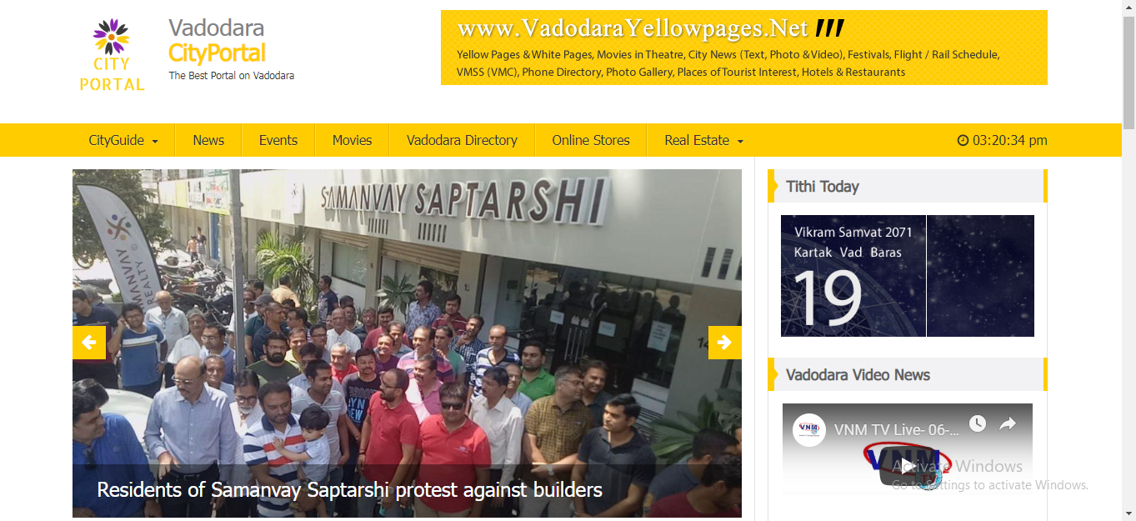

*Figure 5.1 (Website Home Page)*

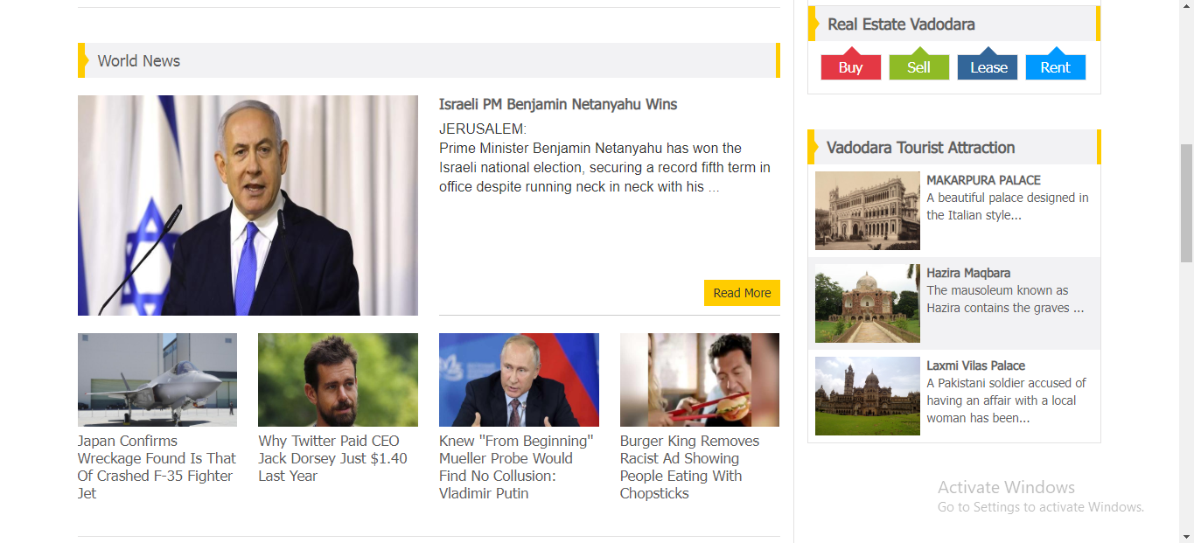

*Figure 5.2 (Website Home Page)*

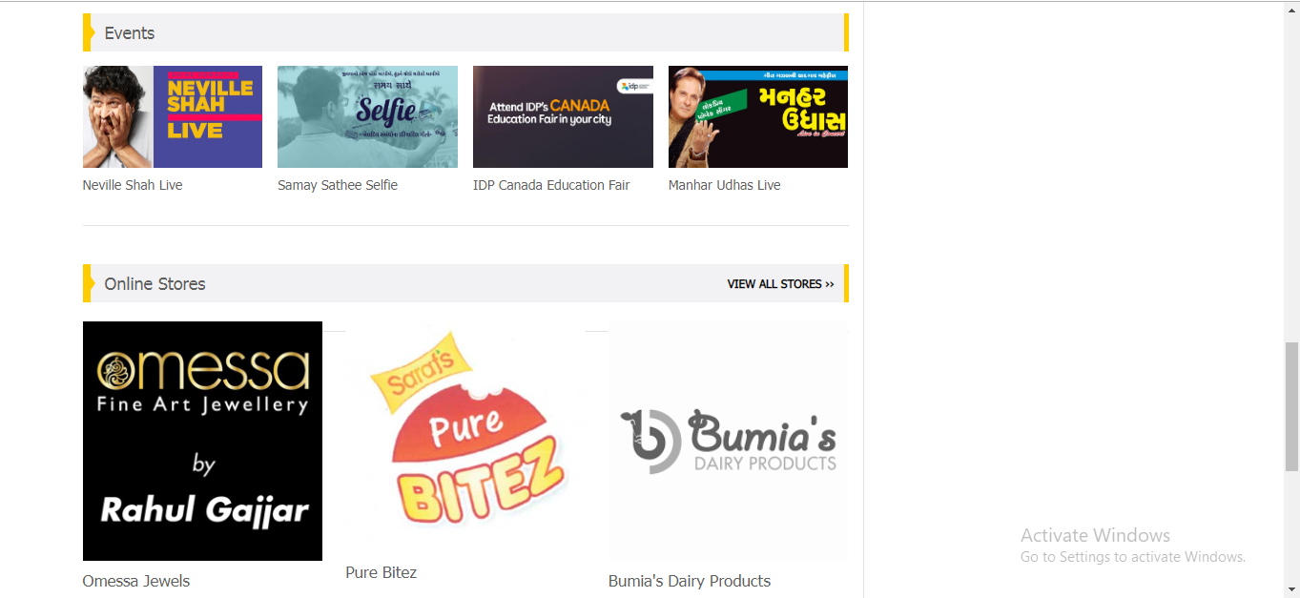

*Figure 5.3 (Website Home Page)*

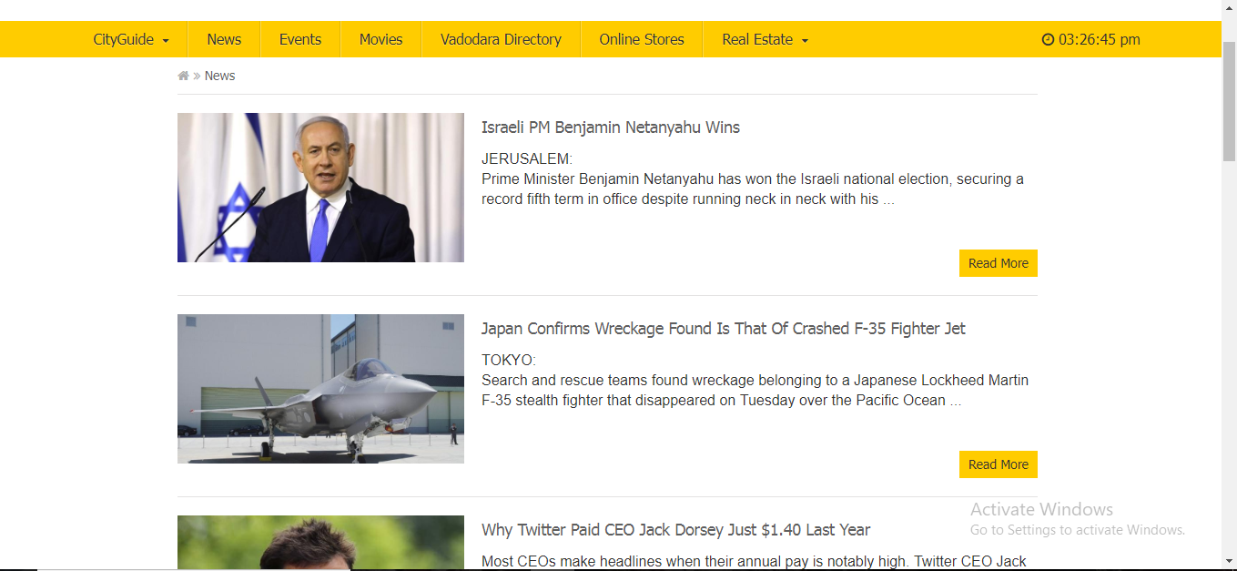

*Figure 5.4 (Website News Module)*



*Figure 5.5 (Website Online Store)*

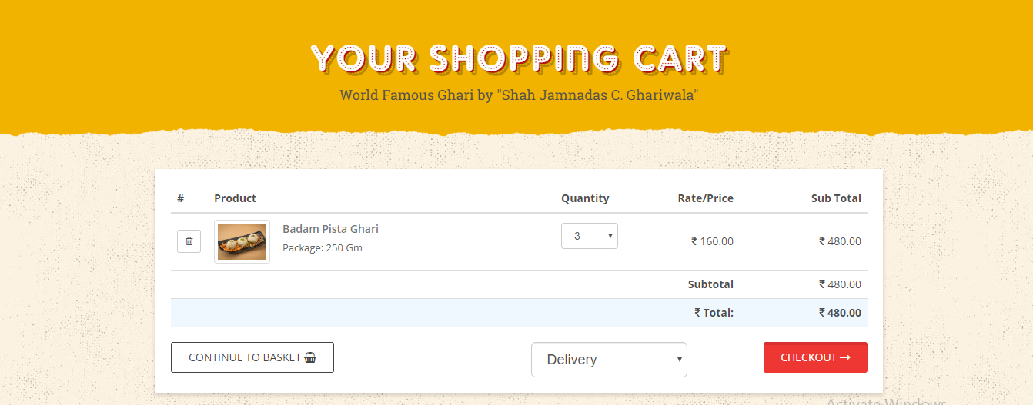

*Figure 5.6 (Website Online Store Cart)*

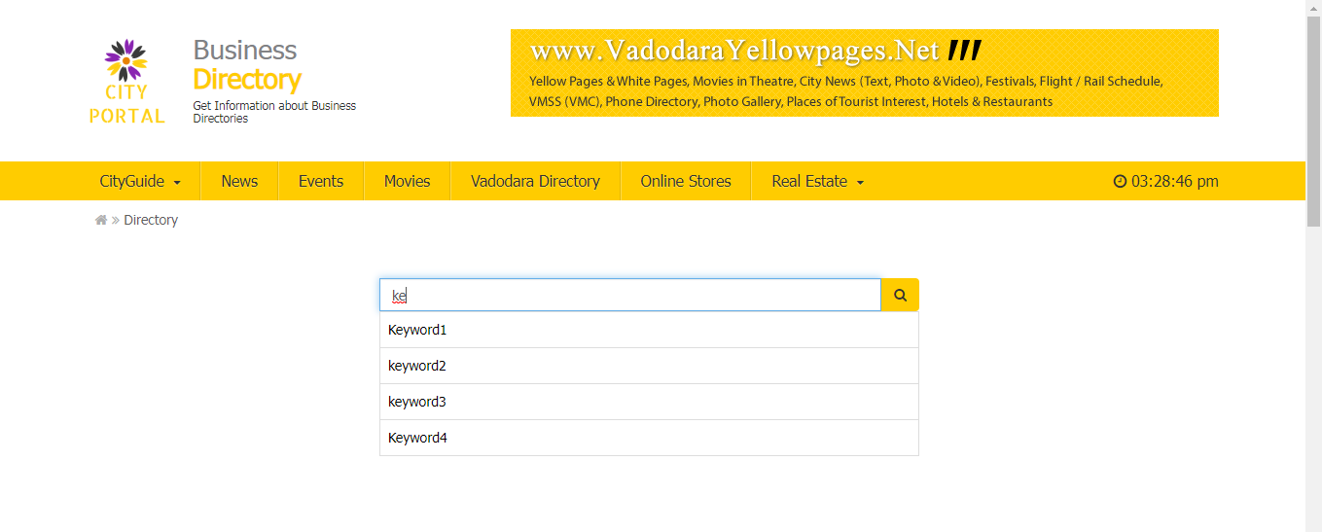

*Figure 5.7 (Website Business Directory Module)*

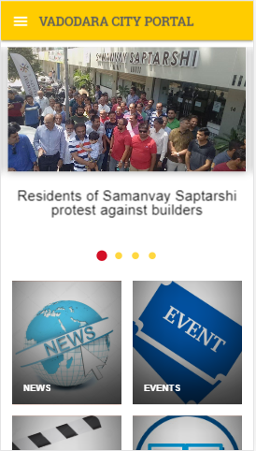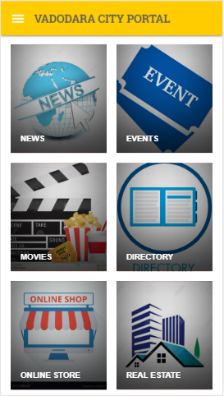

*Figure 5.8 (Mobile Application Home Page)*

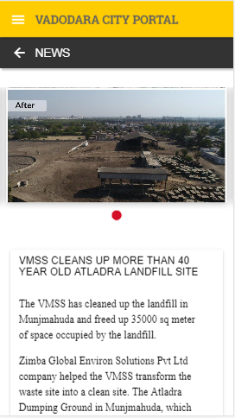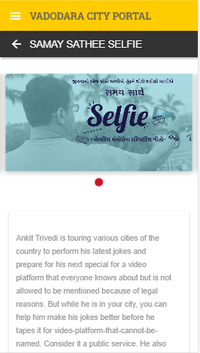

*Figure 5.9(Mobile News and Event Module)*

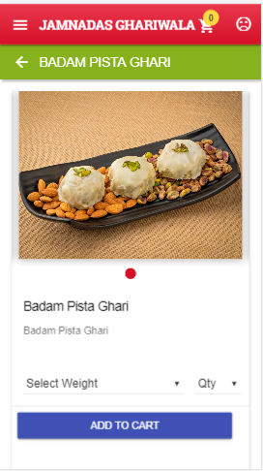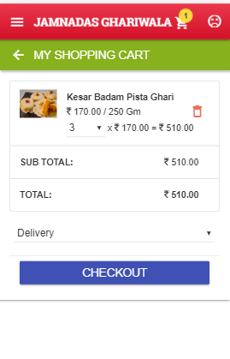

*Figure 5.10 (Mobile Online Store Module)*

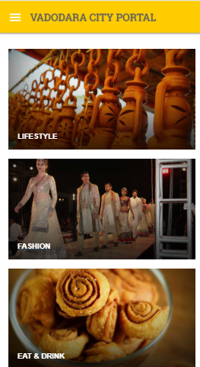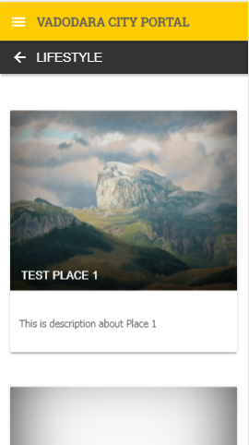

*Figure 5.11 (Mobile City Guide Module)*

# CONCLUSION:

Thus, City Portal proves to be useful System for both the tourist and the local peoples in the city for getting the guide about the city and knowing their city more deeply.

Many new existing features have been added so that the User can easily get what he or she wants easily and quickly. There is possibility that many more features can be added to the System.

Thus, Our System will solve many Problems of Users and with the help of different modules it would effectively save time of the Users.

**APPENDIX A: WEBLIOGRAPHY:**

* https://www.javatpoint.com/java-tutorial
* https://www.javatpoint.com/spring-tutorial
* https://www.w3schools.com/
* https://spring.io/